January 2019
Issue #128

In This Issue:
The Third of a 3 Part Series on Supergraphics in Healthcare.
For the FREE Report,
Selecting Appropriate Art for Your Health Care Facility visit
www.montenagler.com
Upcoming Events:
Fine Art Photography with a Master/ Schoolcraft College March 11, 2019; 6pm - 10pm
Cost: $49
Jeffress Center Building
18600 Haggerty, Liv., MI 48152
734-462-4676

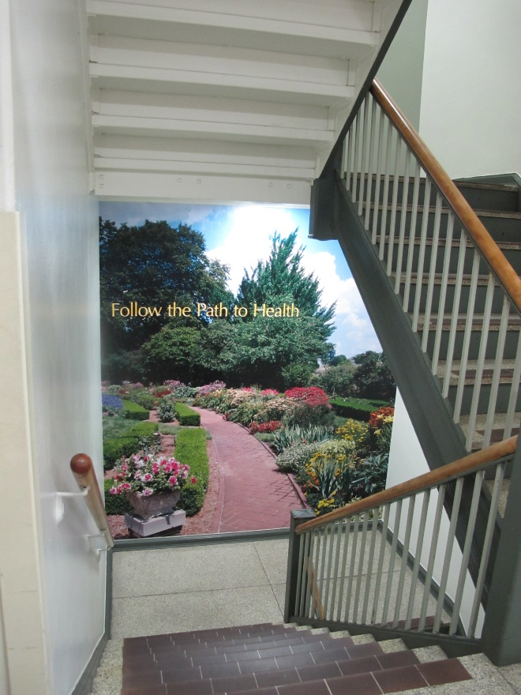
Supergraphic Stairwell Wall Mural -9.5'x10.5’
Simplifying Supergraphics In Healthcare Environments Part 3
by: Carolyn Fleetwood Blake | Originally posted March 30, 2018
Cost Considerations
For some projects, keeping within budget can seem like the steepest hill to climb. However, additional strategic choices can be made to help bring supergraphics to life.
The most powerful way to ensure integrated artwork fits into the budget is to build art into the design documents as early as possible and identify the substrates as finishes.
If an art consultant will be engaged in the project, the design team should involve the art consultant early, as well. The images can be pulled into the artwork budget, while the substrate and installation labor remain in the construction budget. This “divide and conquer” approach reduces the budget impact to any one line item. Art consultants can also provide an allowance for the types of images that would be needed, and this information could be included in the design documents.
If the design team has an in-house graphic designer, the team can keep the images in the architectural or interior design scope without relying on subcontractors or the owner to engage a graphic designer as a separate service. Often, the graphic designer can use relatively inexpensive stock images to create a collage that can scale up to the desired size. Pursuing the option of a manufacturer’s image library also reduces costs while streamlining the process, and the team can be confident of a successful installation since the image resolution is controlled by the same party responsible for printing.
Generally speaking, the larger the supergraphic, the more expensive the cost of purchasing the image. However, when compared to purchasing original artwork of a similar size or visual impact, the cost is typically significantly less. A building owner could expect to pay tens of thousands of dollars for a 40-foot-long piece of original art, but the purchase price of an image for a similarly sized supergraphic might cost $4,000 to $7,000.
Bringing Supergraphics to Life
Supergraphics are a powerful addition to any project. Although much has to be considered when introducing them to a design, following the steps outlined will simplify the process. By integrating art from the outset, being strategic in selection of the graphics, and researching the performance of a substrate, it’s possible to create a solution that best fits a project’s design concept and constraints.

“We want to positively impact people’s lives through the power and appreciation of art.”

